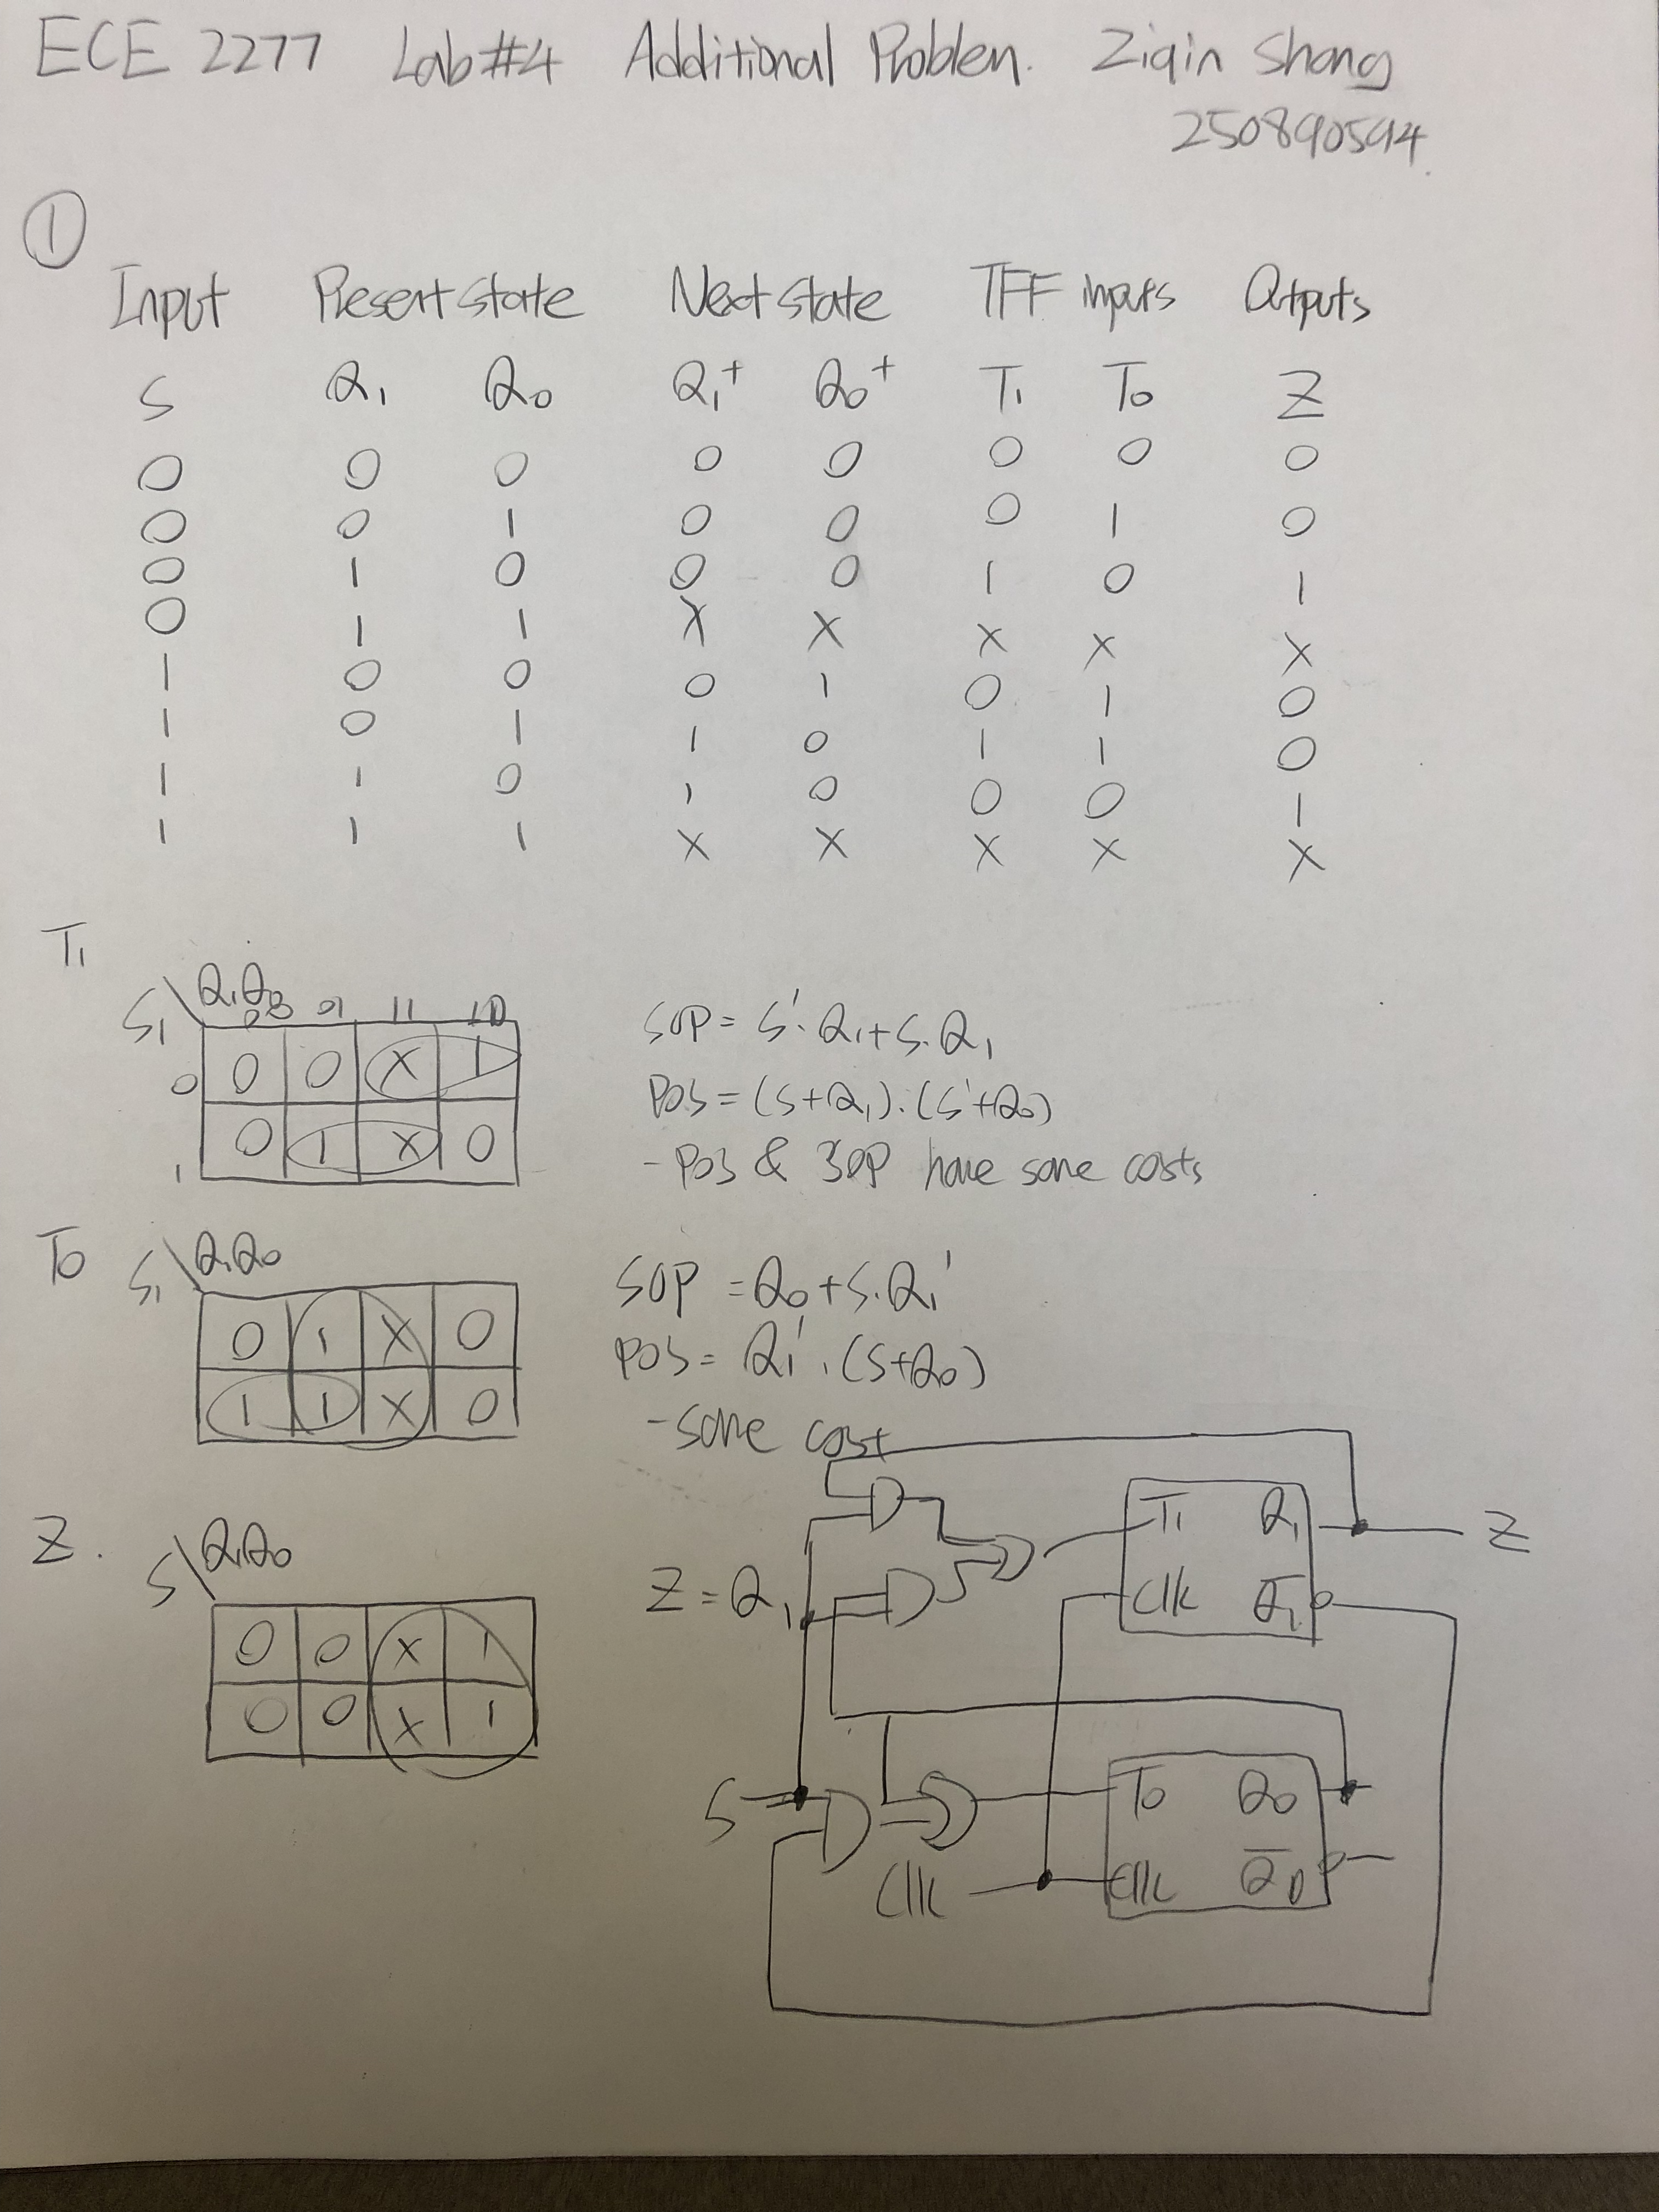

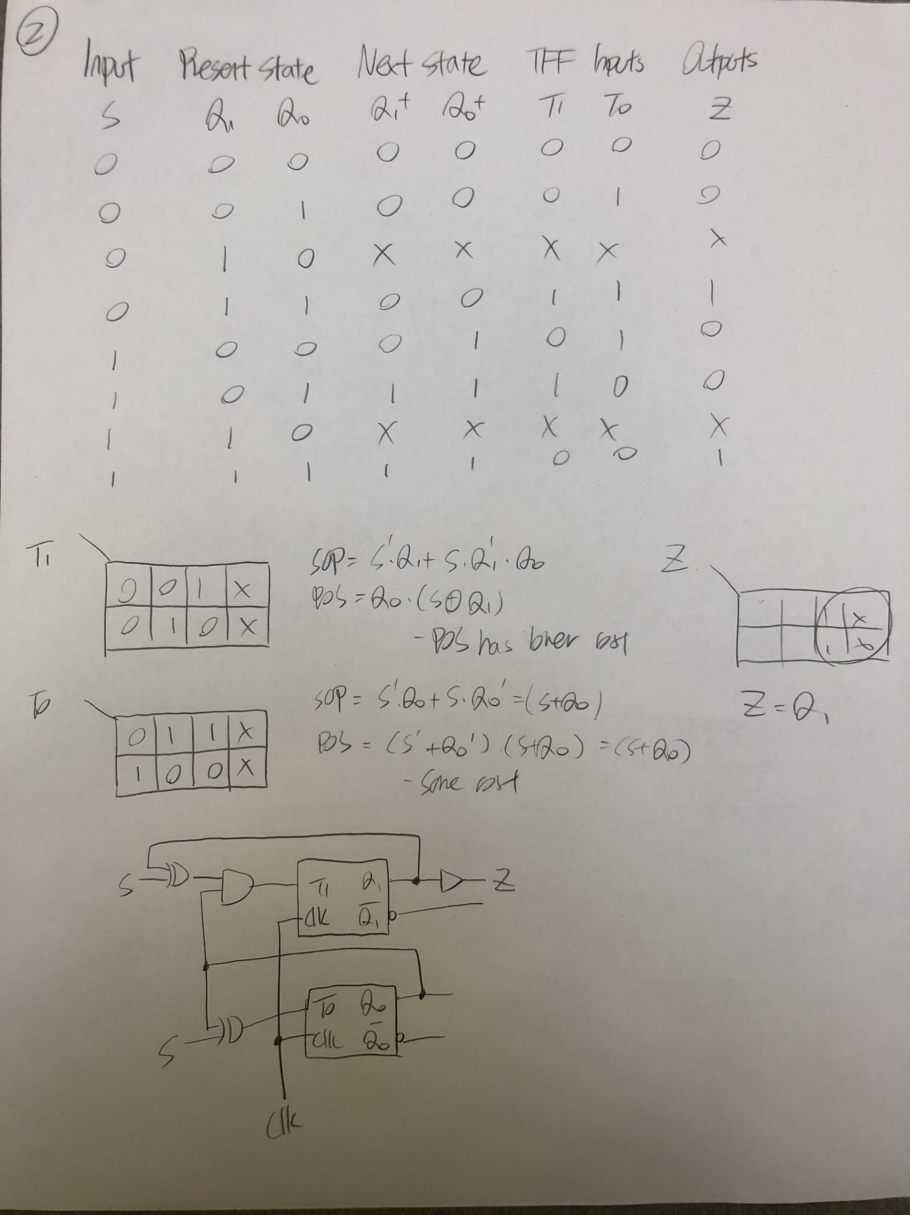

3a. these two circuits work similarly with counters, when input is 1, present state goes to next state until the maximum and stop there, which differs from a counter since it does not keep going. When input is 0, the circuit go back to the initial state to restart counting.

3b. from the circuits that are derived from first two questions, it is obvious that Q2 is more effective because XOR gates decreases the cost of commercial circuit dramatically.

ZIQIN SHANG 250890694